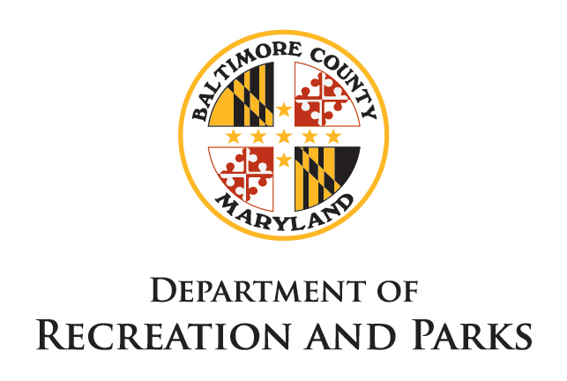
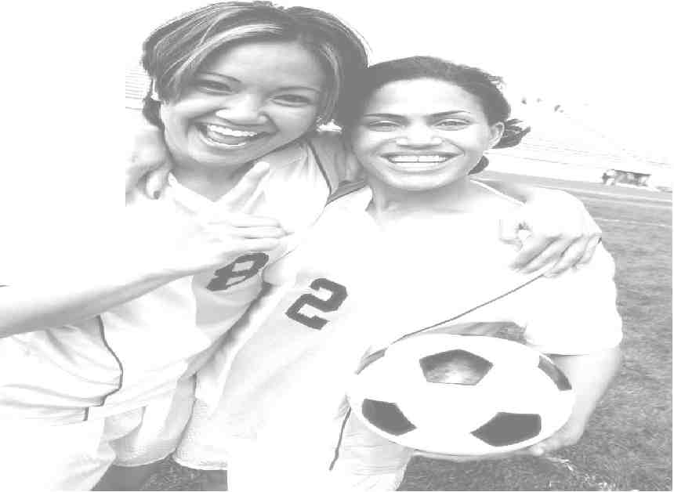
Greater Loch Raven Recreation Council
Baltimore County Department of Recreation and Parks



IMMACULATE HEART OF MARY / LOCH RAVEN EAGLES FALL 2020 GIRLS SOCCER
LEARN THE SKILLS OF SOCCER IN A POSITIVE LEARNING ENVIRONMENT WHILE COMPETING IN TRAVEL LEAGUE COMPETITION. NO PRIOR EXPERIENCE IS NECESSARY AND ALL ABILITY LEVELS WELCOME.
We accept Online and mail-in registrations. Spots for all ages filled on a first come first served basis.
ACCEPTING ONLINE REGISTRATIONS NOW
VISIT OUR WEBSITE - www.glrrc.com

PROGRAM | AGES *On or Before 07/31/2020 | Cost
KICKERS | 4-5 YEARS OLD | $60
CLINIC | 6-7 YEARS OLD | $75
U10 U12 U14 | 8-14 YEARS OLD | $90

Our Kickers is specially designed to teach soccer skills to younger players. Girls receive a ball, trophy, and a T-shirt!
Clinic, U10, U12, and U14 play in the Archdiocese of Baltimore Soccer Program (ABSP) travel league against other local teams of similar experience and ability level. Some teams may participate in additional travel leagues and tournaments. Our focus is training players to compete at their own highest level in a positive learning environment. ABSP coaches are certified through the Catholic Youth Organization.
FOR MORE INFO CALL 410.887.5309 OR SEE WWW.GLRRC.COM
Or email : glrrc12@gmail.com
Should you require special accommodations (i.e. sign language interpreter, large print, etc,) please call 410-887-5309 or Therapeutic Office 410-887-5370, TT/Deaf 410-887-5319. These programs are designed to provide a healthy and enjoyable leisure experience for your child. However, they are not designed to provide child care. Therefore, parents are encouraged to discuss attendance expectations with their children. Department staff cannot detain youth wishing to leave at any time.

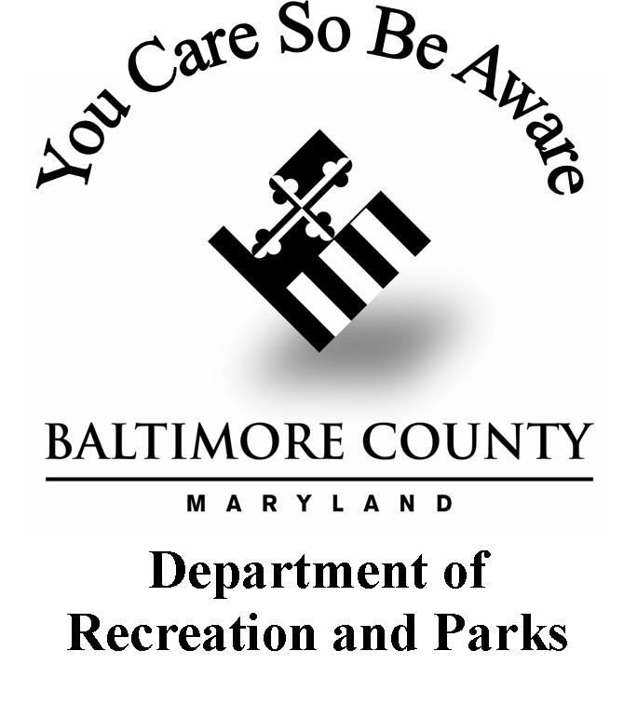
Baltimore County Department of Recreation and Parks
Loch Raven-IHM Girls Soccer Registration Form
Player’s Name:________________________________________ Date of Birth:____/____/____ Age: ____
Parent/Guardian Name(s): ______________________________ Home Phone: (_____)_______________
Street Address: ___________________________ City/State: ______________________ Zip: _________
Cell Phone: (_____)_______________ E-Mail: __________________________ Player Shirt Size: _______
School: _______________________________________________ Years of Playing Experience: _______
I would like to volunteer for the following: Coach Asst. Coach  Team Parent
Emergency/Health Issues
In case of emergency, please notify (if minor/child participant, provide parent’s information or Guardian, as appropriate):
Name ___________________ Relationship _____________ Home Phone________________ Cell Phone __________________
Name ___________________ Relationship _____________ Home Phone________________ Cell Phone __________________
Physician’s Name ______________________________________________ Physician Phone_____________________________
Name of Medical Provider _________________________________ Date of Last Tetanus Immunization ___________________
Any medical, psychological, or behavioral conditions we should be aware of (bee stings, food allergies, etc.)?____________________________
1. Are there any medical or health factors or limitations that might affect your child’s performance in this activity? ___ Yes ___ No
2. Is your child taking any medication that might affect her safety or performance in this activity? ___ Yes ___No
3. Does the participant require special accommodations (due to a disability)? ___ Yes ___No
If “Yes”, please state special requirements __________________________ ____________________________________________________.

In case of emergency, I for myself and/or participant (if a minor/child), and my personal representatives, heirs and assigns, (severally and collectively “I” for this registration form) give permission for an activity representative to call 911 and transport participant to a hospital. I shall inform the Recreation Council in writing, of any medical or health conditions of participant that occurs or develops and which could affect participant’s safety, performance or participation in or throughout the activity.

Signature of Parent/Guardian:__________________________________________________ Date: ____/____/______
ACKNOWLEDGEMENT, WAIVER AND RELEASE OF LIABILITY
I hereby confirm participant is in good health and able to participate in the activity. I acknowledge the activity may involve risk and danger of bodily injury or death. I fully accept and acknowledge the activities may involve risk, and I hereby assume the risk and responsibility for all dangers and risks associated with the participant in the activity. I further understand that concussion information is available at www.cdc.gov/concussion.

I acknowledge Baltimore County, Maryland, the recreation council, and their respective employees, directors, officers, volunteers, members and any other participant, entity, party or person involved in any regard with the activity or the activity premises and their respective agents, personal representatives, heirs, employees, contractors, successors, and assigns (each on “activity representative” and collectively the “activity representatives”), shall not be responsible or liable in any regard or manner for any and all property damage or bodily injury(including serious injury or even death) incurred by participant or any party related thereto as a result of his/her participation in the activity.

I have read, fully understand, and hereby freely sign, approve of, and agree to the terms of this registration form. I hereby unconditionally release, discharge, covenant not to sue, waive my rights and remedies, and agree to hold harmless the activity representatives from any and all claims, costs, demands, losses, damages, or expenses associated with, in whole or in part, participant’s involvement with the activity. I certify all answers and information provided on this registration form are to the best of my knowledge true and correct throughout the activity. I shall inform the recreation council in writing if any information provided in this registration form is incorrect or changes through the course of the activity. I understand Baltimore County and/or the recreation council do not perform criminal and/or background checks on activity representative. I shall present a government issued photo identification card including, but not limited to, my drivers license, passport, or United States Visa to the activity representative for review, if requested, at the time I submit this registration form to the recreation council.
Signature of Parent/Guardian:____________________________________________ Date: ____/____/______
Print Name of Signatory: _______________________________________________ Relationship to Participant: ________________________

Return to:
GLRRC Girls Soccer Program
Loch Raven Recreation Center
1801 Glen Keith Blvd Baltimore, MD 21234
Checks payable to GLRRC Girls Soccer
Rec Center Office hrs: Monday-Friday ▪10am-3pm Rec Center: 410-887-5309 www.glrrc.org
Soccer Info:
Cost: Kickers:$60 Clinic:$75 U10-U12-U14:$90

Cash Check Amount: $_____ Kickers Clinic U10 U12 U14

